Anjing

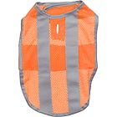

Petco Reflective Orange

Rp. 45.000

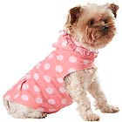

Petco Smoochie Pooch Pink Polkadot

Rp. 45.000

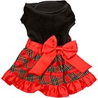

Holiday Party Dog Dress

Rp. 50.000

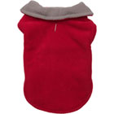

Petco red & Gray Reversible Cozy Coat

Rp. 45.000

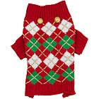

Petco wag-a-tude Holiday Argyle Dog Sweater

Rp. 50.000

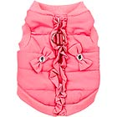

Petco Smoochie Pooch Coral Bomber Dog Jacket

Rp. 75.000

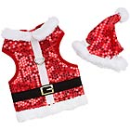

Petco wag-a-tude Sequin Santa Dog Haress&Hat

Rp. 40.000

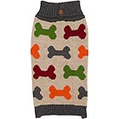

Petco wag-a-tude Multi Bone Dog Sweater

Rp. 65.000

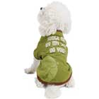

Star Wars Yoda Dog T-Shirt

Rp. 55.000

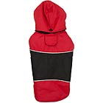

Petco red & black water Resistant Dog Coat

Rp. 65.000

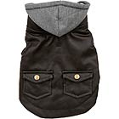

Petco wag-a-tude Brown Leather Dog Jacket

Rp. 55.000

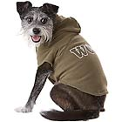

Petco Wag-a-tude Woof Dog Hoodie

Rp. 45.000

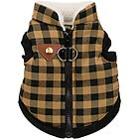

Petco Wag-a-tude Checkered Shearling Bomber Dog Jacket

Rp. 65.000

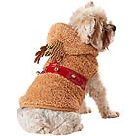

Petco wag-a-tude Fuzzy Reindeer Hoodie

Rp.55.000

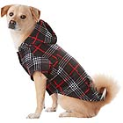

Petco Wag-a-tude black plaid Dog Hoodie

Rp. 45.000

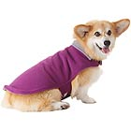

Petco Purple & Gray Reversible Cozy Coat

Rp.45.000

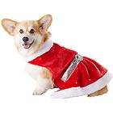

Petco Holiday Mrs Claus Dog Costume

Rp. 55.000

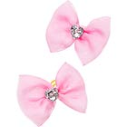

Petco Smoochie Pooch Pink Rhinestone Dog Hairbows

Rp. 25.000

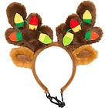

Petco Holiday Light Up Dog Antlers

Rp. 28.000

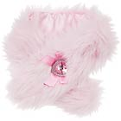

Petco Smoochie Pooch Pink Faux Dog Scraf

Rp.25.000

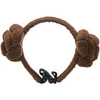

Star Wars princess Leia Dog Headband

Rp. 40.000

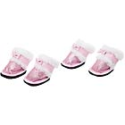

Petco Smoochie pooch Pink Sparkle Boot Dog Shoes

Rp. 65.000

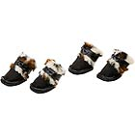

Petco Smoochie Pooch Leopard Faux Fur Dog Shoes

Rp. 65.000

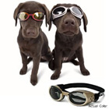

Doggles Protective eyewear for dogs

Rp. 50.000

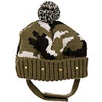

Petco wag-a-tude Camo Beanie

Rp.35.000

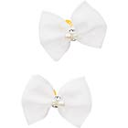

Petco Smoochie Pooch Pearl Dog Hairbows

Rp.25.000

ANJING

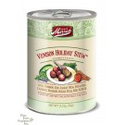

Merrick Venison Holiday Stew Grain Dog Food

Rp. 55.000

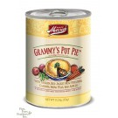

Merrick Geammy’s Pot Pie Grain Dog Food

Rp. 60.000

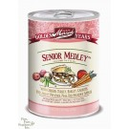

Merrick Senior Medley Dog Food

Rp. 55.000

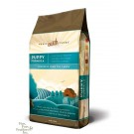

Merrick Qhole Earth Farms Puppy Dog Food

Rp. 85.000

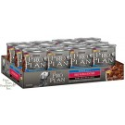

Pro Pllan Senior Beef & Rice Dog Food

Rp. 95.000

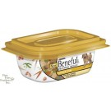

Purina Beneful Prepared Meals Chicken With Rice Dog Food

Rp. 60.000

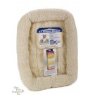

Four Paws K-9 Keeper Sleeper

Rp. 175.000

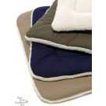

Dog Gone Smart Bed Co Small

Rp. 95.000

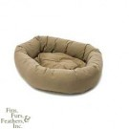

Dog Gone Smart Bed Donut

Rp. 150.000

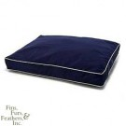

Dog Gone Smart Bed Co Large Navy

Rp. 200.000

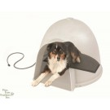

K&H Igloo Style Heated Pad Small

Rp. 123.000

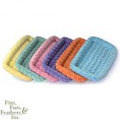

Midd West Metal Quiet time Fur Bed

Rp. 110.000

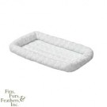

Mid West Metal Product Co

Rp. 150.000

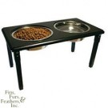

Ethical Pet Products (spot) steel Double Diner

Rp. 230.000

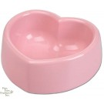

Petmate Melamine Bowls Pink Heart

Rp. 30.000

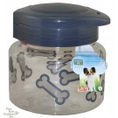

Lixit Dog Treat Jar

Rp. 45.000

KUCING

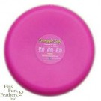

Pet Supply Imports Snuggle Safe Microwave Heat Pad

Rp. 55.000

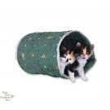

Lazy Pet Cat Racket Tunnel

Rp. 90.000

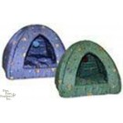

Lazy Pet Kitty Pyramid Assorted Prints

Rp. 150.000

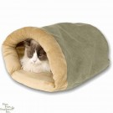

K&H Mfg Kitty Crinkle Sack

Rp. 172.000

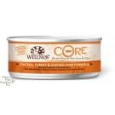

Wellnes Grain Free Core Chicken Turkey&Chicken Liver Formula

Rp. 40.000

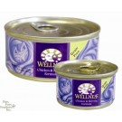

Wellnes Grains Free Chicken & Hearing Formula Cat Food

Rp. 67.000

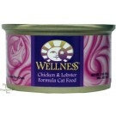

Wellness Chicken Lobster Formula Canned Cat Food

Rp. 75.000

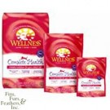

Wellness Cat Complete Health Salmon

Rp. 90.000

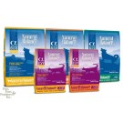

Natural Balance Alpha Cat Grain Free Trout Salmon Whitefish Formula Dry Cat Food

Rp. 67.000